{JSON} Placeholder

Free fake API for testing and prototyping

***Задание:*** Опишите ещё не менее 7 тест кейсов для запроса из задания 1. своими словами в произвольной, но понятной форме.

### HTTP GET REQUEST

1. **GET** **/posts - GET All Posts Info**

**url = “https://jsonplaceholder.typicode.com”**

**{{url}}/post**

**API Response**

**The response for the API request (GET /post) in JSON format represent all Posts Info with the following properties: “userId”, “id”, “title”, “body”.**

**StatusCode – 200 OK**

**Run script:**

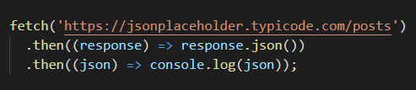

**Output (partial):**

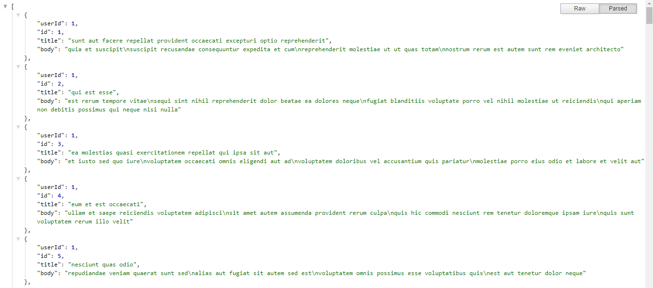

1. **GET** **/posts/1 - GET Posts Info by postId**

**url = “https://jsonplaceholder.typicode.com”**

**{{url}}/post/:postId (e.g. :postId = 1)**

**API Response**

**The response for the API request (GET /post/1) in JSON format represent Posts Info by postId with the following properties: “userId”, “id”, “title”, “body”.**

**StatusCode – 200 OK**

**Run script:**

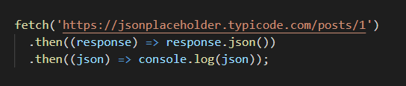

**Run script: Output (partial):**



1. **GET** **/posts/1/comments - GET All Comments for Post Info by postId**

**url = “https://jsonplaceholder.typicode.com”**

**{{url}}/post/:postId/comments (e.g. :postId = 1)**

**API Response**

**The response for the API request (GET /post/1/comments) in JSON format represent All Comments for Post Info by postId with the following properties: “postId”, “id”, “name”, “email”, “body”.**

**StatusCode – 200 OK**

**Run script:**

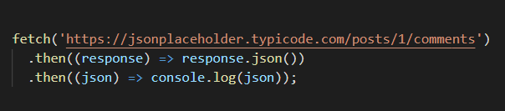

**Output (partial):**

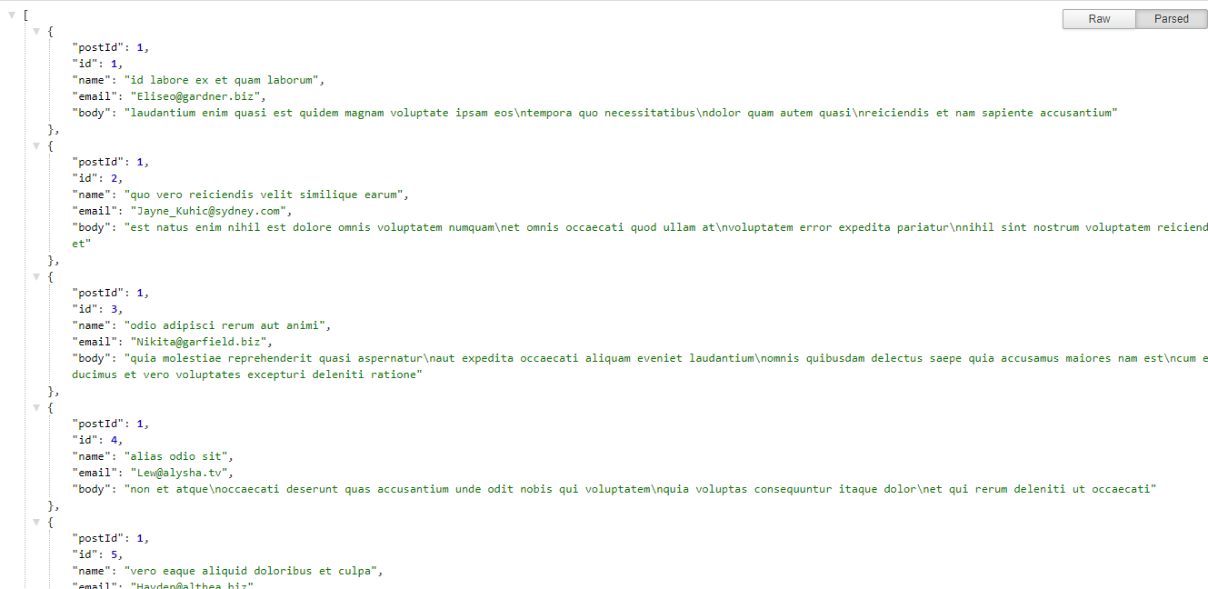

1. **GET** **/albums - GET All Albums Info**

**url = “https://jsonplaceholder.typicode.com”**

**{{url}}/albums**

**API Response**

**The response for the API request (GET /albums) in JSON format represent All Albums Info with the following properties: “userId”, “id”, “title”.**

**StatusCode – 200 OK**

**Run script:**

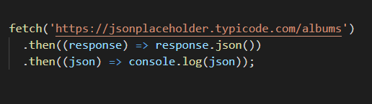

**Output (partial):**

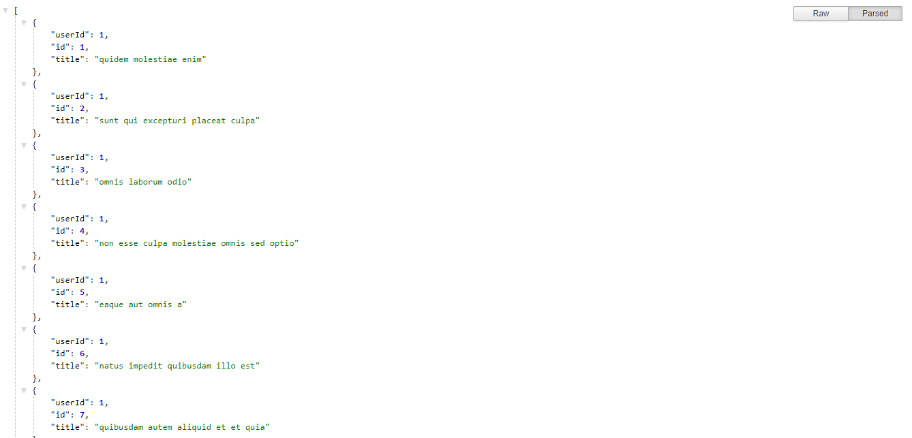

1. **GET** **/albums/1/photos - GET All Photos for Albumn by albumId**

**url = “https://jsonplaceholder.typicode.com”**

**{{url}}/albums/:albumId /photos (e.g.: albumId = 1)**

**API Response**

**The response for the API request (GET /albums/1/photos) in JSON format represent All Photos for Albumn by albumsId with the following properties: “albumId ”, “id”, “title”, “url”, “thumbnailUrl”.**

**StatusCode – 200 OK**

**Run script:**

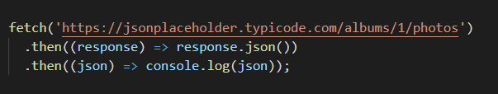

**Output (partial):**

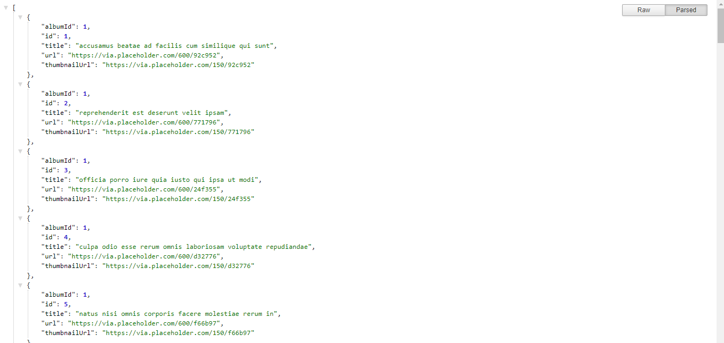

1. **GET** **/photos - GET All Photos Info**

**url = “https://jsonplaceholder.typicode.com”**

**{{url}}/photos**

**API Response**

**The response for the API request (GET /photos) in JSON format represent All Photos Info with the following properties: “albumId”, “id”, “title”, “url”, “thumbnailUrl”.**

**StatusCode – 200 OK**

**Run script:**

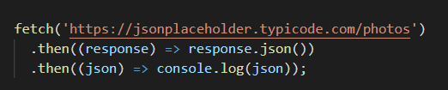

**Output (partial):**

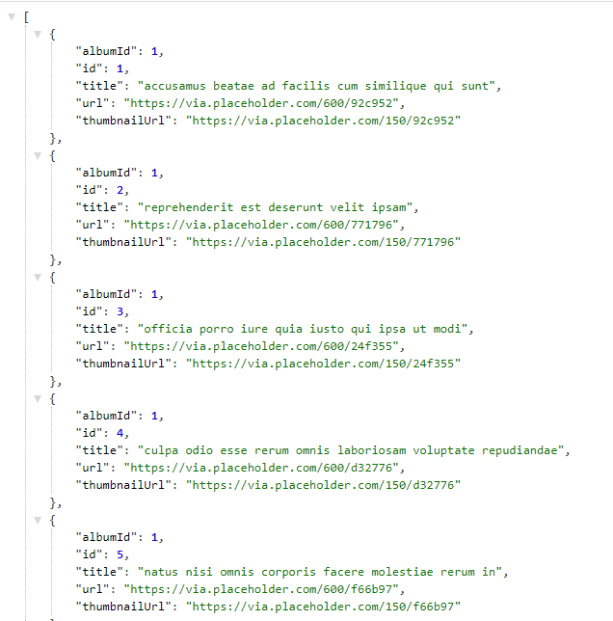

1. **GET** **/todos - GET All Todos Info**

**url = “https://jsonplaceholder.typicode.com”**

**{{url}}/todos**

**API Response**

**The response for the API request (GET /todos) in JSON format represent All Todos Info with the following properties: “userId”, “id”, “title”, “completed”.**

**StatusCode – 200 OK**

**Run script:**

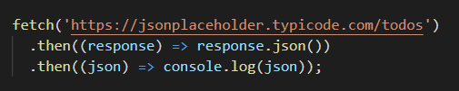

**Output (partial):**

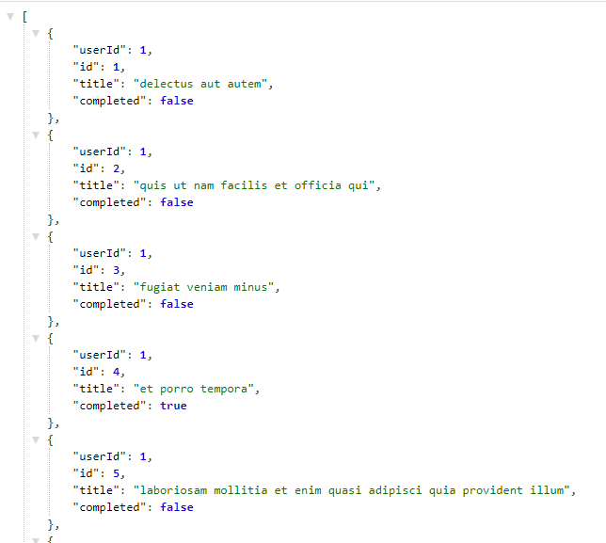

1. **GET** **/users - GET All USER Info**

**url = “https://jsonplaceholder.typicode.com”**

**{{url}}/users**

**API Response**

**The response for the API request (GET /users) in JSON format represent All USERS Info with the following properties: “userId”, “name”, “email”, “adress” (“street”, “suite”, “city”, “zipcode”, “geo” (“lat”, “lng”)), “phone”, “website”, “company” (“name”, “catchPhrase”, “bs)”.**

**StatusCode – 200 OK**

**Run script:**

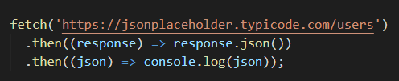

**Output (partial):**

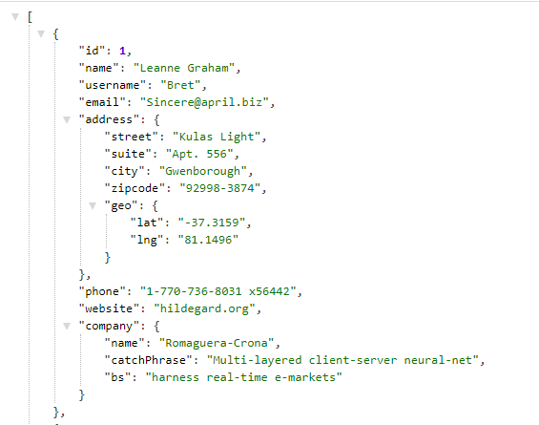

### HTTP POST REQUEST

1. **POST** **/posts - Creating a new post info**

**url = “https://jsonplaceholder.typicode.com”**

**{{url}}/posts**

**API Response**

**The response for the API request (POST /posts) in JSON format for creating a new post info with the following properties: “userId”, “title”, “body”.**

**StatusCode – 201 Created**

**Run script:**

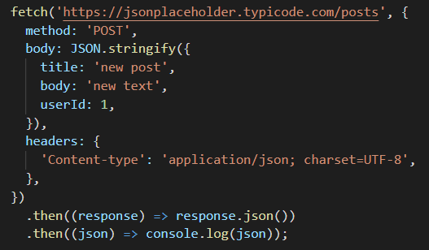

**Output:**

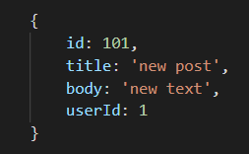

1. **POST** **/users - Creating a new user**

**url = “https://jsonplaceholder.typicode.com”**

**{{url}}/users**

**API Response**

**The response for the API request (POST /users) in JSON format for creating a new user with the following properties: “userId”, “name”, “email”, “adress” (“street”, “suite”, “city”, “zipcode”, “geo” (“lat”, “lng”)), “phone”, “website”, “company” (“name”, “catchPhrase”, “bs)”.**

**StatusCode – 201 Created**

**Run script:**

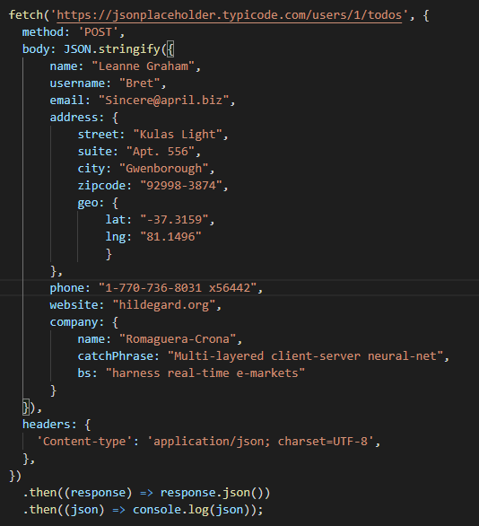

**Output:**

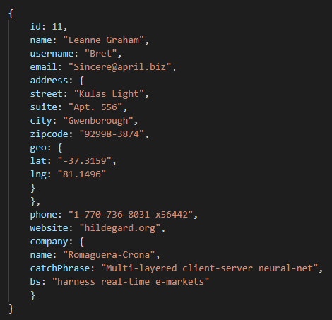

1. **POST** **/users/1/todos - Creating a new todo for user by userId**

**url = “https://jsonplaceholder.typicode.com”**

**{{url}}/users/:id/todos (e.g.: :userId - 1)**

**API Response**

**The response for the API request (POST /posts/1/todos) in JSON format for creating a new todo for user by iserId with the following properties: “userId”, “title”, “completed”.**

**StatusCode – 201 Created**

**Run script:**

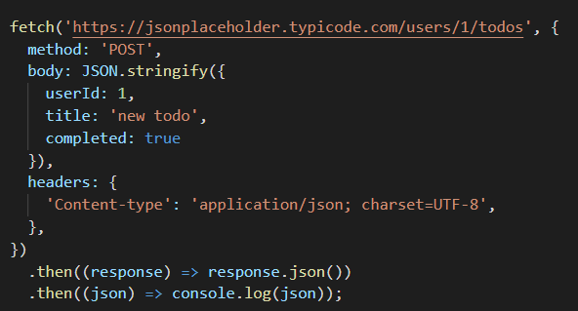

**Output:**

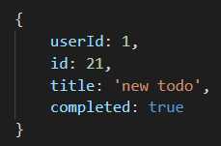

### HTTP PUT REQUEST

1. **PUT** **/posts/1 - Updating the post info by userId**

**url = “https://jsonplaceholder.typicode.com”**

**{{url}}/posts/:userId (e.g.: userId = 1)**

**API Response**

**The response for the API request (PUT /posts) in JSON format for updating the post info by userId with the following properties: “userId”, “title”, “body”.**

**StatusCode – 200 OK**

**Run script:**

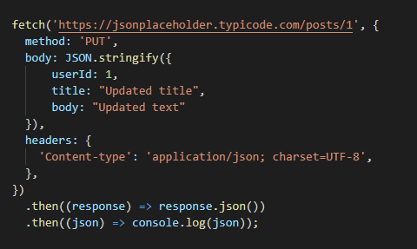

**Output:**

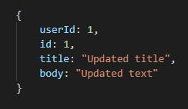

### HTTP PATCH REQUEST

1. **PATCH** **/posts/1 – Partial updating the post info by userId**

**url = “https://jsonplaceholder.typicode.com”**

**{{url}}/posts/:userId (e.g.: userId = 1)**

**API Response**

**The response for the API request (PATCH /posts/1) in JSON format for partial updating the post info by userId with the following properties: “userId”, “title”, “body”.**

**StatusCode – 200 OK**

**Run script:**

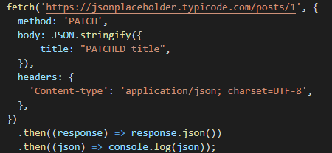

**Output:**

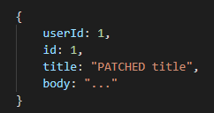

### HTTP DELETE REQUEST

1. **DELETE** **/posts/1 – DELETE the post info by userId**

**url = “https://jsonplaceholder.typicode.com”**

**{{url}}/posts/:userId (e.g.: userId = 1)**

**API Response**

**The response for the API request (DELETE /posts/1) in JSON format for deleting the post info by userId with the following properties: “userId” (“id”, “title”, “body”).**

**StatusCode – 200 OK**

**Run script:**

